Meigan First

Alejandra Duffy

Michael Fuller

In designing our Zen Garden page, we want it to feel like you are starting at the top of a mountain and then descending as you scroll the page. There will be clouds and birds that pass by at the top, and a river at the bottom. The text content will follow the contours of the mountain in the large view, and be more block like in the small view. There will be a path that comes down the mountain, the path to enlightenment, so to speak.

Font ideas:

Frederica the Great: Heading text.

Oswald: Body text.

Color schemes: (We don’t plan to use every single color here we are still narrowing down the final selections, but this gives a good idea of the overall idea.)

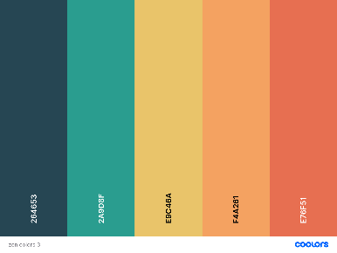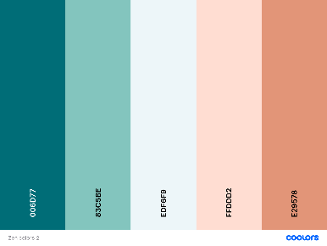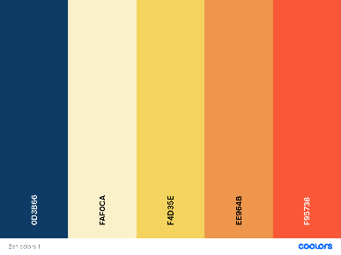

Wireframes:

Large View:

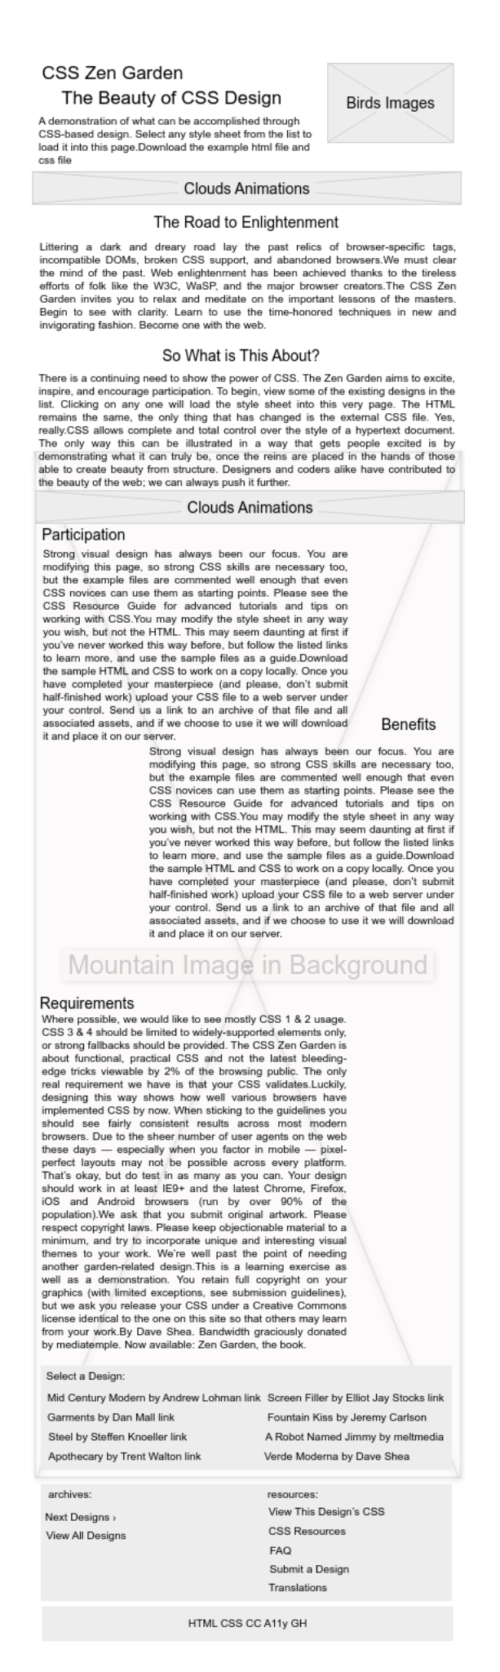Small View:

2 options.